**Why SVM?**

We have couple of other classifiers there, so why do we have to choose SVM over any other?

Well! It does a pretty good job at classification than others. for example, observe the below image.

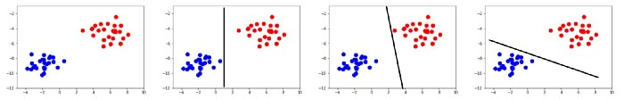

We have a dataset which is linearly separable from +’s and — ’s, we can separate the data using logistic regression (or other) we may get something like above (which is reasonable).

This is how SVM does

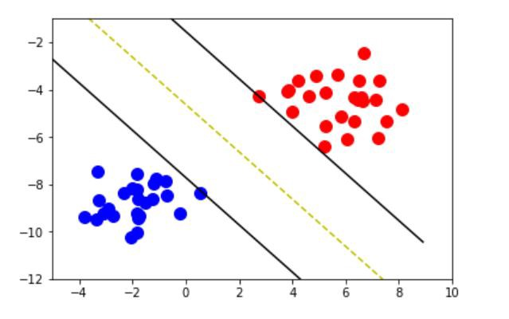

This is a high-level view of what SVM does. The yellow dashed line is the line which separates the data (we call this line ‘***Decision Boundary’ (Hyperplane)***in SVM), The other two lines (also***Hyperplanes***) help us make the right decision boundary.

*So, what the heck is hyperplane?*

The answer is “*a line in more than 3 dimensions”* (in 1-D it’s called a point, in 2-D it’s called a line, in 3-D it’s called a plane, more than 3 - Hyperplane).

How is SVM’s hyperplane different from linear classifiers?

Motivation: **Maximize margin**: we want to find the classifier whose decision boundary is furthest away from any data point. We can express the separating hyper-plane in terms of the data points that are closest to the boundary. And these points are called **support vectors.**

We would like to learn the weights that maximize the margin. So, we have the hyperplane!

*Margin is the distance between the left hyperplane and right hyperplane.*

These are couple of examples that I ran SVM (written from scratch) over different data sets.

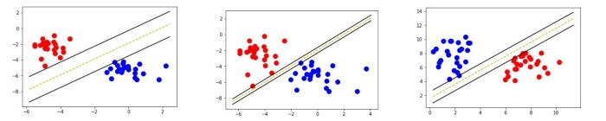

Okay, you get the idea what SVM does, ***now Let’s talk about how it does???***

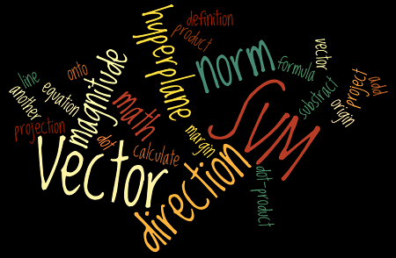

First, I want you to be familiar with the above words so let’s complete that

Vector is an n-dimensional object which has magnitude (length) and direction, it starts from origin (0,0).

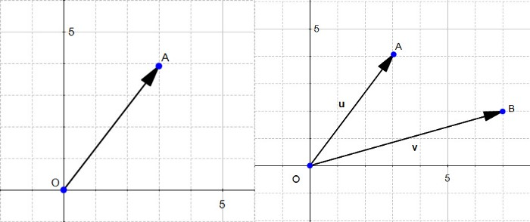

u and v are vectors

The magnitude or length of a vector u (O-A distance) is written ∥ u∥ and is called its norm.

The direction of the vector u is defined by the angle θ with respect to the horizontal axis, and with the angle α with respect to the vertical axis.

**Addition and subtraction of Vectors**

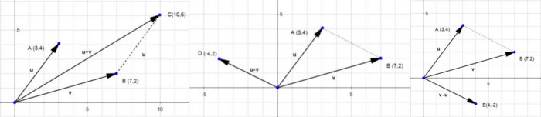

Addition (Left) Sub (Centre and Right)

**Dot product of vectors:**

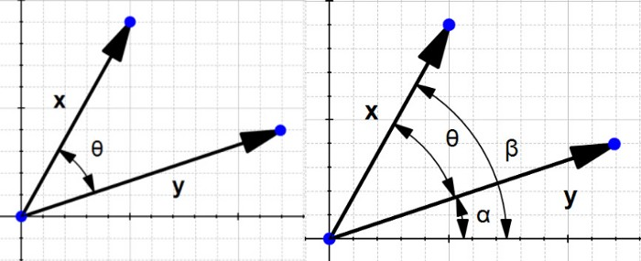

Dot product of x and y (finding the **θ**)

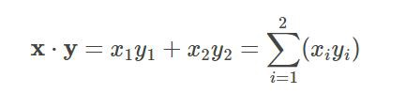

If we work on a bit, we get this **‖x‖‖y‖cos(θ)=x1y1+x2y2**

**∥x∥∥y∥cos(θ)=x⋅y**

**The orthogonal projection of a vector.**

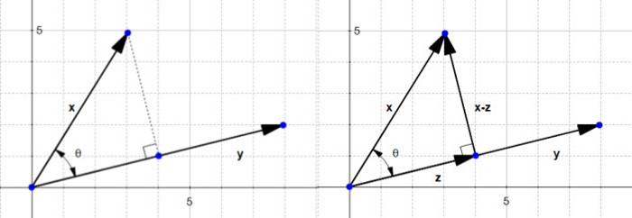

Vector **x** onto vector **y** (Left), new vector **z**(right)

Why are we interested by the orthogonal projection? Well, it allows us to compute the distance between **x** and the line which goes through **y**(x-z).

The SVM hyperplane

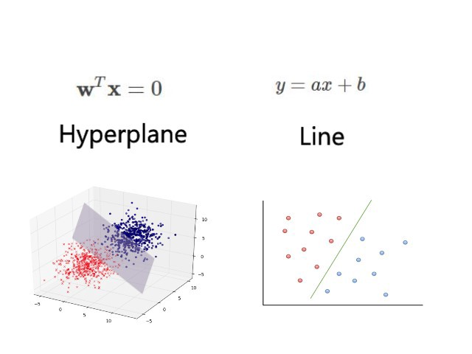

The line equation and hyperplane equation — same, it’s a different way to express the same thing,

It is easier to work on more than two dimensions with the hyperplane notation. Now we know how to draw a hyperplane with the given dataset, *so, what’s next??*

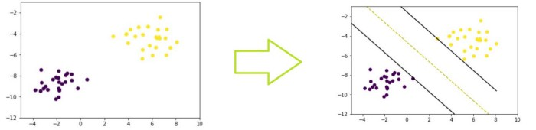

We have a dataset; we want to draw a hyper plane something like above (which separates the data well).

*How can we find the optimal hyperplane (yellow line)?*

If we maximize the margin(distance) between two hyperplanes, then divide by 2 we get the decision boundary.

*How do we maximize the margin?*

Let’s take only 2 dimensions, we get the equation for hyper line is

w.x+b=0 which is same as w.x =0 (which has more dimensions)

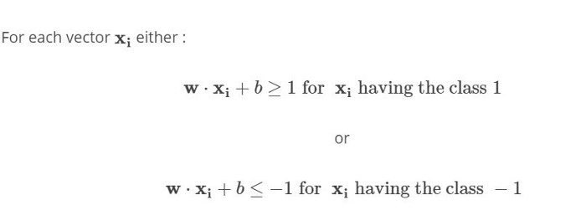

Rules for separating dataset

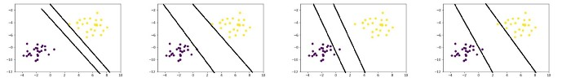

First two are following our Rules while others aren’t

if w.x+b=0 then we get the decision boundary → The yellow dashed line

if w.x+b=1 then we get (+) class hyperplane for all positive(x) points satisfy this rule (w.x+b ≥1)

if w.x+b=-1 then we get (-) class hyperplanefor all negative(x) points satisfy this rule (w.x+b≤-1)

Observe this picture.

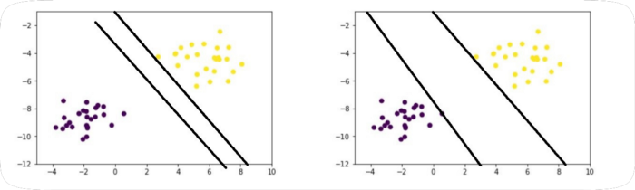

Above both are following our rules so how do I pick the max margin one???

Answer: pick one which has minimum **Magnitude of w**

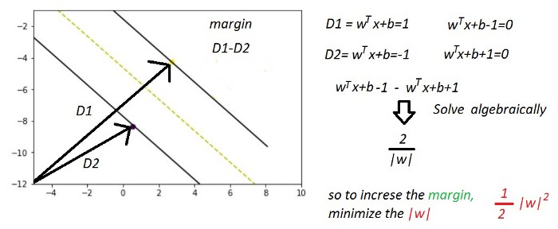

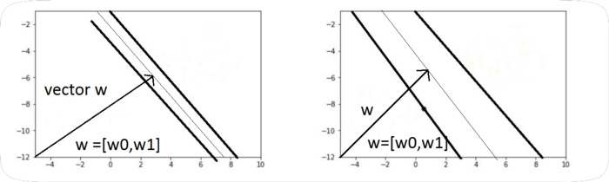

||W|| should be minimum.

This is the final picture

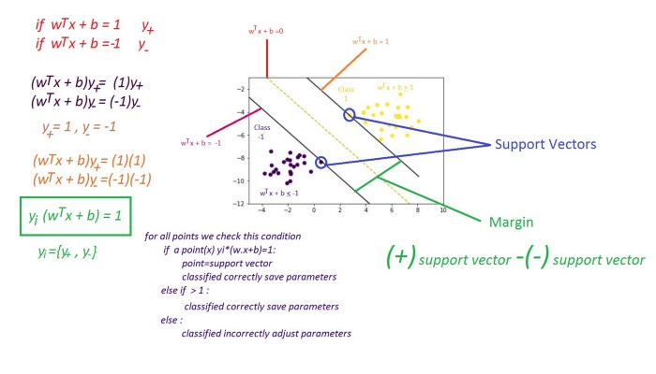

So, either we save the w and b values and keep going or we adjust the parameter (w and b) and keep going. Another optimization problem, SVM.

Adjusting parameters? Sounds like **Gradient descent,** right? Yes!!!

It is a convex optimization problem which surely gives us global minimum value. Once its optimized we are done!

*So, what’s next?* Predicting!

Now we give an unknown point, and we want to predict whether it belongs to positive class or negative class.

